Mid Way Report
on
Zero Touch Device Onboarding using PKI, mTLS & WebSocket

1. Introduction / Background
With the rapid growth of IoT and industrial devices, securely onboarding devices at scale has become an important challenge. Traditional onboarding methods depend on shared credentials, activation keys, or manual registration processes which are difficult to manage in large deployments. This project focuses on building a secure onboarding workflow using PKI, X.509 certificates, mutual TLS (mTLS), and WebSocket Secure (WSS).

2. Problem Statement / Domain
The existing onboarding architecture introduces several security and scalability limitations:
- A common device certificate is shared across multiple devices.
- Users are required to manually activate devices.
- Activation keys increase operational complexity.
- Large-scale deployments become slower and difficult to manage.
The proposed solution replaces manual onboarding with a certificate-based Zero Touch Onboarding architecture.

3. Techniques / Tools / Technologies Used
Tools and Technologies used during this internship/project:
• PKI & OpenSSL: Explored Public Key Infrastructure (PKI), created Root CA and Intermediate CA, and generated X.509 certificates for secure device identity and authentication.
• Trustpoint & CMP: Explored certificate provisioning workflows and CMP-based certificate management for secure onboarding.
• Backend Development: Used Golang to explore modular onboarding-agent and backend service development for device-side communication and authentication.
• mTLS Authentication: Implemented certificate-based mutual TLS authentication between device and cloud for secure communication.
• WebSocket Secure (WSS): Used secure bidirectional communication between device and cloud to support onboarding status updates and real-time communication.
• Frontend Development: HTML, CSS, JavaScript and React was used for developing device-side and cloud-side UI components for monitoring successfully onboarded devices.
• Version Control: Used GitHub for code management and collaboration.
• Collaboration: Additional platforms like Jira were used to track project progress and Confluence was used for documentation purposes.

4. Block Diagram / Architecture / Methodology
Current onboarding architecture:
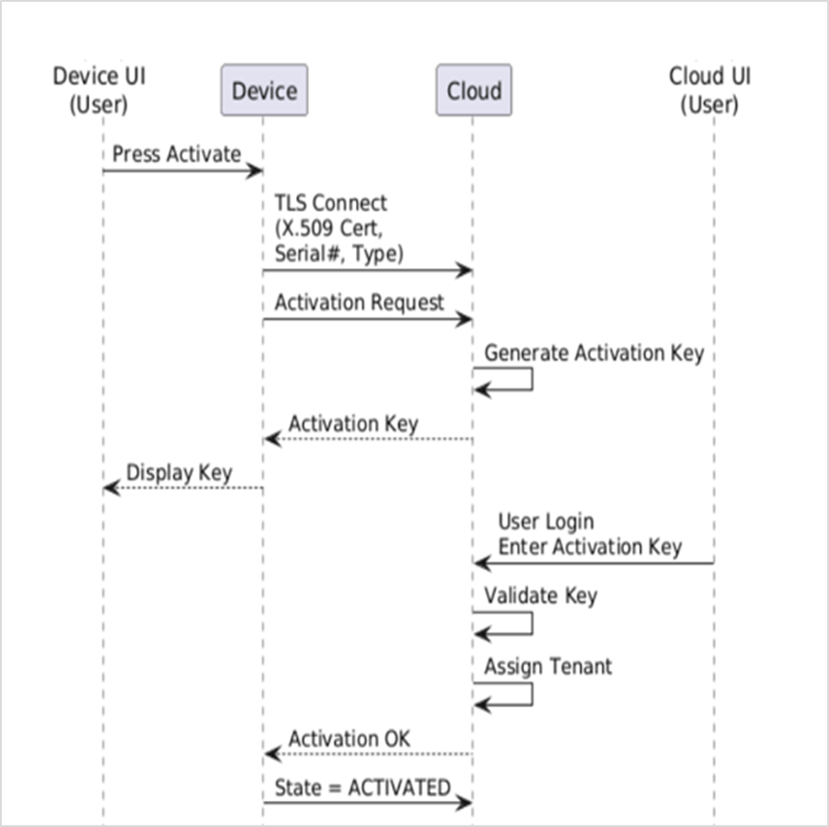
Figure 1: Current Onboarding Architecture
- Shared certificates reduce security.
- Manual onboarding increases deployment effort.
- Activation-key workflow creates operational friction.
- Scalability becomes difficult in large deployments.

Proposed Zero Touch Onboarding architecture:
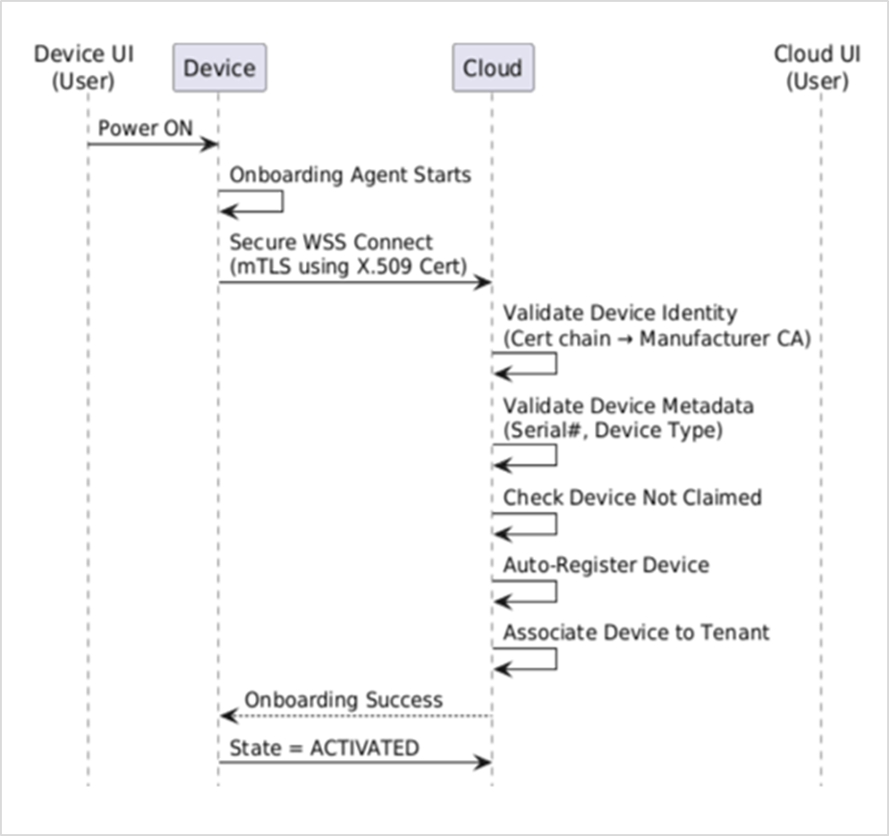
Figure 2: Proposed Zero Touch Onboarding Architecture
- Unique certificate per device improves security.
- Automatic onboarding removes manual activation steps.
- WebSocket enables real-time onboarding communication.
- mTLS provides strong certificate-based authentication.
- Architecture supports scalable industrial deployments.
Work completed till midway phase:
- Studied the existing onboarding architecture and identified its limitations.
- Explored PKI concepts, X.509 certificates, and certificate chains.
- Generated Root CA and Intermediate CA using OpenSSL.
- Implemented and tested mTLS communication flow.
- Explored WebSocket Secure (WSS) communication in Golang.
- Designed Zero Touch Onboarding architecture and onboarding lifecycle.

